Chloe Jenkins

Professor Ramos

ENG 1301-43480

20 March 2016

Coldplay Concert

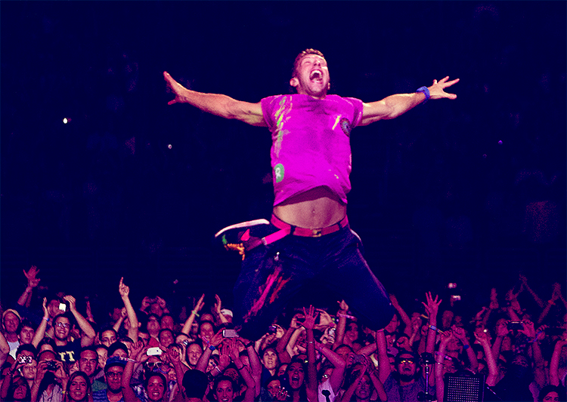

Concerts can be some of the greatest events a person will ever experience. Music helps people of all ages to feel related to and understood. The lyrics an artist produces can greatly impact their fans, negatively and positively, and music is a way to escape the problems of this world and just focus on the beauty of it. For example, the band Coldplay puts on amazing concerts that take people to another place. This picture found in an article by Roadie #42 expresses the excitement music brings to people’s lives.

There are several elements that make musical performances so spectacular. The simplest, less personal aspect is the lighting and effects. The bright purple light flashed across the audience gives a fun, theatric atmosphere to the show. It is almost pitch black in the back yet bright and exciting closer to the stage. If an artist did a whole set with all of the house lights on, the concert attendees would probably feel uncomfortable. The dim room with flashes of neon gives the audience the freedom to dance or jump without feeling as if all eyes are on them. The band Coldplay is known for their extravagant effects and performance skills. Their music is the focus of their show and the beautiful array of lights is the icing on the cake. With that said, the atmosphere of the concert greatly depends upon the volume of the band and the lighting displays.

The second part of the image, the ecstatic fans, completely captures the feelings a person gets when attending a show. It appears that everyone in this picture is smiling. Many have their phones out in order to encapsulate this brilliant moment forever. Their faces clearly display the happiness in their hearts and the emotional high they’re experiencing. A lot of people have their hands raised to show the adrenaline and energy running through their veins. Not one person appears to be bored or disappointed as they gaze, entranced by the lead singer. Although the people at the concert have never met before, there is an unspoken bond created between them as they all ­­­sing along. They are all part of a momentous, beautiful occasion.

The most attention-getting component of this picture is obviously the lead singer, Chris Martin, leaping in the air. Anyone can tell by his face expression that he is invested in this moment. His mouth is open and his eyes are squeezed shut. The ways his arms are flung behind him is dramatic and intense. There is cohesion between him and the lights. He also has neon paint splatters on his clothes and a vibrant colored shirt. Every aspect of this man draws the fans in and makes others wish they were there. One of the best parts of a concert is belting out the song lyrics along with the artist. The scene is energizing and alluring. Just looking at this photo makes a person’s hair stand on end. Without the commitment of the band, the concert would just be a bunch of expensive displays and disappointed fans. The members of Coldplay, as seen here in Chris Martin, are so passionate about their music, making their concerts powerful and entertaining.

Never has there been a greater depiction of the feelings involved in concerts as this picture. The colors and effects make the concert relaxing and enjoyable. Audience members are pumped up and totally mesmerized by the show. In the middle of his exhausting concert, Chris Martin is literally jumping in the air. Coldplay is one of the most talented bands in the world and the members take their jobs very seriously. Anyone who enjoys music needs to attend at least one spirited, exhilarating show such as the one in the image.

Work Cited

Roadie #42. "The Return of Oldlay." *The Coldplay Timeline*. Coldplay, 15 July 2012. Web. 01 Mar. 2016. http://timeline.coldplay.com/roadie-42-blog-175.